Tode-SIOST
Hardware Development

Tode Side-IO Screw Terminals [ #SIOST ]

by TGit-Tech [ http://www.tgit-tech.com ]
Build Version: 231T / Last Updated: 2023-01-29

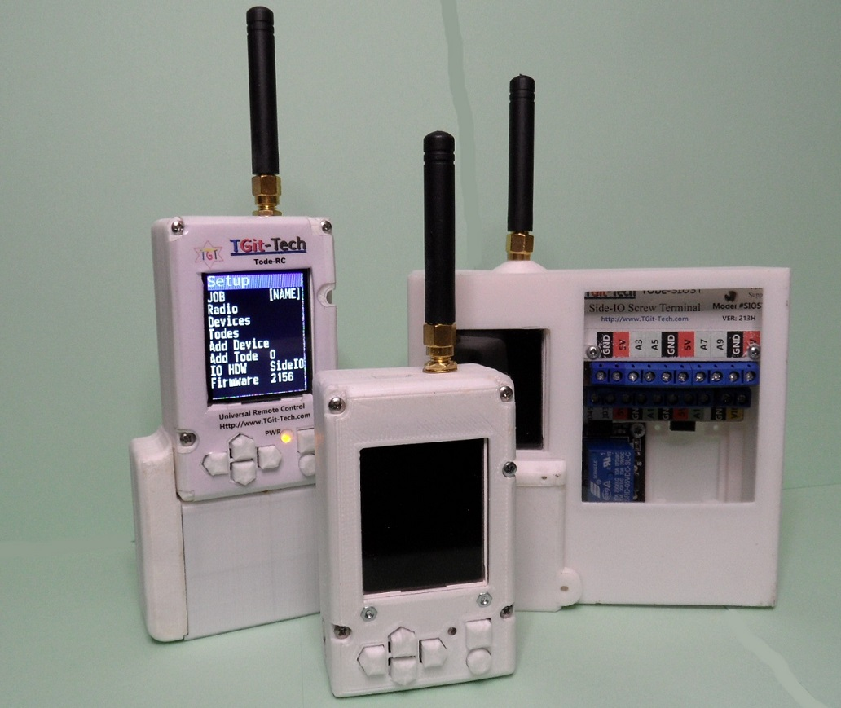

Table of Contents
1. Introduction 2
2. Bill of Materials (BOM) $15 4
2.1 Parts $7 4
2.2 Supplies $5 4
2.3 3D-Prints $3 5
3. PCB Assembly 6
3.1 Preparation 7
3.1.1 Print Stickers on Self-Adhesive Shipping Labels 7
3.1.2 Obtain SIOST PCB(s) 7
3.2 Assembly 7
3.2.1 Bottom-PCB Label, Terminals & Power 8
3.2.2 Top-PCB Terminals & Pin-Header 8
3.2.3 Top to Bottom PCB with 6P Female Header 8
3.2.4 Side-IO Header & (2) Relay 3P Female Headers 8
3.3 Schematic & Layout 9
4. Final Assembly 9
4.1 Final Assembly Steps 9
4.1.1 Power Module Cover 10
4.1.2 Adjust Power Supply Module 10
4.1.3 Screw PCB-Assemblies to Base 10
4.1.4 Cover Windows in Cover 10
4.1.5 Install KBHood 11
4.1.6 Install KBCover, Tode & Relays (Optional) in Base 11
4.1.7 Attach Cover to SIOST-Base 11

Introduction

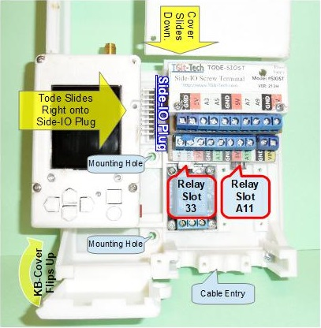

- The Tode Project is a Universal Platform of...
  - Face - UI Options
  - Tode – Backplane with optional Radio & Arduino Micro-Controller
  - Extensions - IO Interfaces, Battery Trays

Face Options ( User Interface )
Model | Components | Resources
#TFT18KB6 | 1.8” TFT LCD Color Screen  (6) Key keypad | Design Files https://github.com/TGit-Tech/Tode-RC
#COVER | A Cover Only | Not available at this time

Tode Models (post-fix RC=Remote/Radio Control equipped)
Model | Components | Resources
Tode #AMP | Arduino Mega Pro (AtMega2560) | Not available at this time
Tode-RC #AMPE32T30 | Arduino Mega Pro (AtMega2560)  Ebyte E32-433T30D Radio (1W/30dbm) | Design Files https://github.com/TGit-Tech/Tode-RC  Firmware https://github.com/TGit-Tech/Tode-RC-Firmware
Tode-RC #AMPE32T20 | Arduino Mega Pro (AtMega2560)  Ebyte E32-433T20D Radio (250mW/20dbm) | Not available at this time
Tode-RC #AMPXBEE | Arduino Mega Pro (AtMega2560)  Digi Xbee Radio | Not available at this time

SIO Stations ( Input/Output by Todes Side-IO [SIO] plug )
Model | Components | Resources
#SIOST | Screw Terminals | Design Files https://github.com/TGit-Tech/Tode-SIOST
#SIOAP | Aviation Plugs | Not available at this time

The Tode System is licensed under the MIT License. It's hosted on Github.com at:
https://github.com/TGit-Tech/Tode-RC

- See the “Tode General Hardware Development” document for required tools

Bill of Materials (BOM) $15

Parts $7
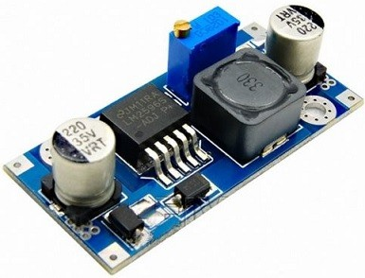  - LM2596 DC-DC Step Down Buck Power Supply Module  - Power In: 3Vdc to 35Vdc  - Power Out: 1.5Vdc to 35Vdc (adjustable)  - Load Amps: 2A to 3A (10W)  - Dimensions: 44mm x 22mm x 12mm (high)  - Temp Range: -40C to 85C  - Pricing: ~ $0.50/each  - http://www.aliexpress.com/item/32668330319.html | 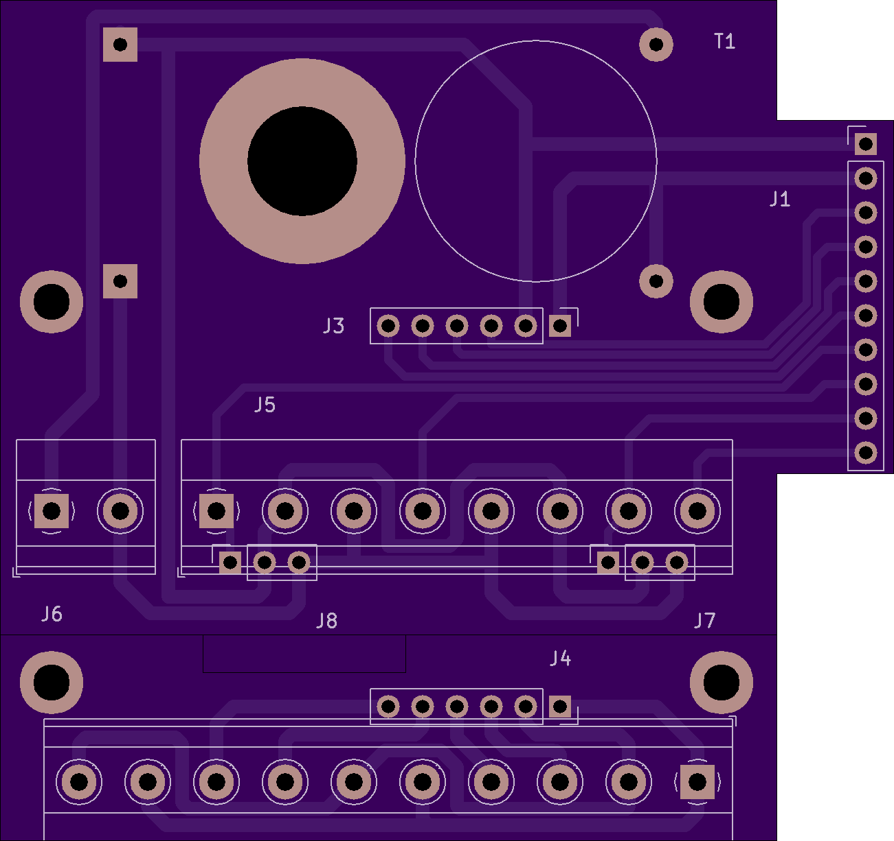  - SideIO #SIOST PCB  - Manufacturer: Oshpark.com  - Pricing: $6.38/ea  - Batch Price: $127.60 per 20

Supplies $5

 | QTY: (9-in² ) Clear Craft Plastic  Grafix Clear Craft Plastic 0.02” thick  For SIOST-Cover.stl Windows  8” x 8” (Pack of 4) = $9.17 ($0.036/in²)  @$0.036/ in² = $0.33 | 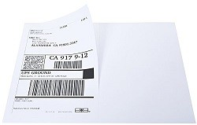 | QTY: (1/2-Sheet) Adhesive Shipping Label  @0.04/sheet = $0.02
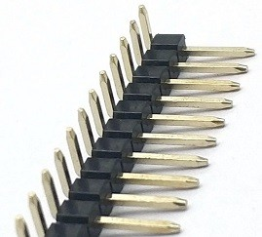 | QTY: (1) 1x10P 90° Male Pin Header  Dupont 2.54mm-Pitch  For Side-IO Plug  @$0.10/ea = $0.10 | 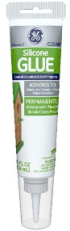 | QTY: (0.1oz) Clear Adhesive Silicone  GE-2708910 Clear Adhesive Silicone  2.8 oz Tube for $6.61  For SIOST-Cover.stl Windows  @$2.36/oz = $0.24
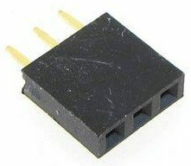 | QTY: (2) 1x3P Female Pin Headers  Dupont 2.54mm-Pitch  For Relay Plug-In  @$0.10/ea = $0.20 | 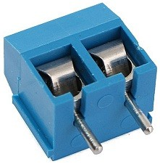 | QTY: (10) Generic 1x2P Screw Terminals  5.08mm Pitch  @$0.10/ea = $1.00  -- or --  QTY: (10) CUI TB007-508-02BE 1x2P Terminals  @$0.30/ea = $3.00
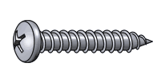 | QTY: (2) #2 x 1/4” Sheet Metal Screws  For SIOST-KBHood.stl  @$0.05/ea = $0.10 |  | QTY: (3) #2 x 5/8” Sheet Metal Screws  For SIOST-KBCover.stl & SIOST-Cover.stl  @$0.05/ea = $0.15
 | QTY: (2) #4 x 1/2” Sheet Metal Screws  For SIOST-CableEntry.stl  @$0.05/ea = $0.10 |  | QTY: (2) #4 x 5/8” Sheet Metal Screws  For SIOST-CableEntry.stl  @$0.05/ea = $0.10
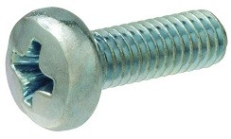 | QTY: (2) #2-56 x 7/8” Machine Screw  For SIOST-PSCover & Terminal Block  @$0.05/ea = $0.10

3D-Prints $3

- 3D Print the Following Files in Folder /3DPrints/stl
  - Priced @ $20/per 1KG Roll
QTY | File Name | Grams | Cost  $0.02/g | Time  HH:MM | Power & Use  $0.01/hr | Total Cost
1 | SIOST-Base.stl | 60-grams | $1.14 | 10h:59m | $0.04 | $1.25
1 | SIOST-Standoff.stl | 5-grams | $0.10 | 00h:54m | $0.01 | $0.12
1 | SIOST-PSCover.stl | 4-grams | $0.08 | 00h:40m | $0.01 | $0.10
1 | SIOST-KBCover.stl | 8-grams | $0.12 | 01h:21m | $0.01 | $0.14
1 | SIOST-KBHood.stl | 2-grams | $0.04 | 00h:20m | $0.01 | $0.05
1 | SIOST-Cover.stl | 40-grams | $0.82 | 05h:35m | $0.03 | $0.90
1 | SIOST-CableEntry.stl | 12-grams | $0.24 | 01h:30m | $0.01 | $0.26
4 | SIOST-CablePlug.stl | 1-gram | $0.08 | 00h:06m | $0.01 | $0.09

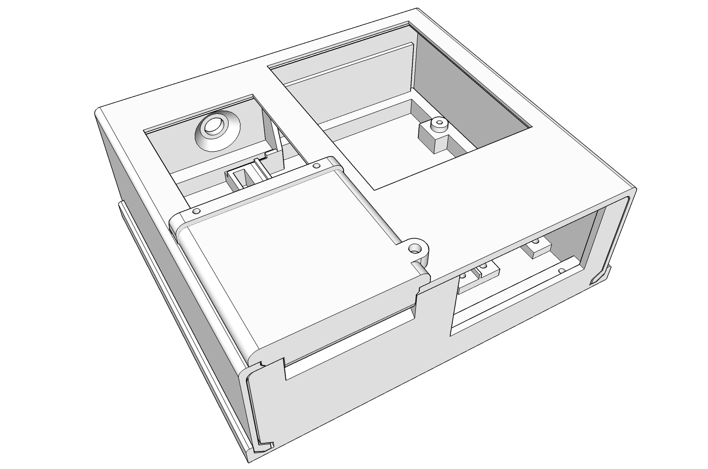

PCB Assembly
Printed Circuit Boards can be either ordered from a Custom PCB Manufacturer or created with a CNC Router.

- Custom Manufactured PCB
  - Benefits - Custom PCB manufacturing is by far the better approach.
    - Copper through holes provide better connection
    - A Silk Sscreen for better corrosion resistance
    - Far easier to solder

  - Common Custom Manufacturing Businesses
    - https://oshpark.com/
    - https://jlcpcb.com/
    - https://www.pcbway.com/orderonline.aspx
    - https://www.customcircuitboards.com/
    - https://custompcb.com/

- CNC Routed PCB
  - Benefits
    - Generally cheaper by a couple dollars
    - Instant product (No shipping/manufacturing wait time)
    - Good for designing phases; not good for finished design production.

Preparation

Print Stickers on Self-Adhesive Shipping Labels  - Printer – Color Laser  - Media – Self-Adhesive Shipping Label Paper  - File - /docs/Tode-SIOST Stickers.pdf | 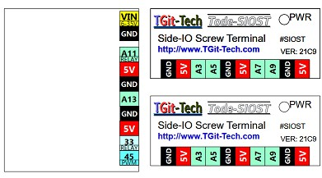
Obtain SIOST PCB(s)  - Purchase or Make the PCB Design File at:  - /Tode-SIOST/kicad/SIOST/SIOST/output/  - File contains (2) PCB(s) as shown in picture | 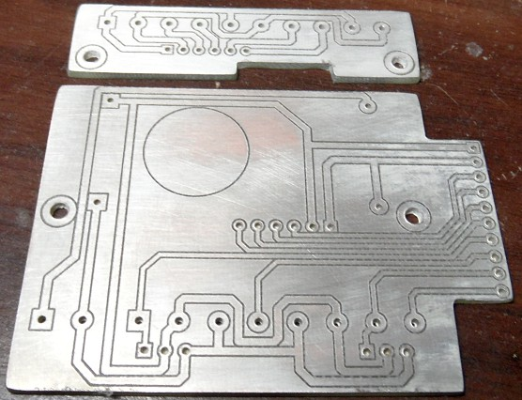

Assembly

Bottom-PCB Label, Terminals & Power  - Cut & Stick Terminal Label from printer sticker sheet  - Install and Solder the Left-8 and Right-2 Screw Terminals  - NOTE: The right-2 screw terminals are separated.  - Install and Solder the LM2596 DC-DC Power Module  - Use (4) Individual 1P Male Header sections and solder both ends. | 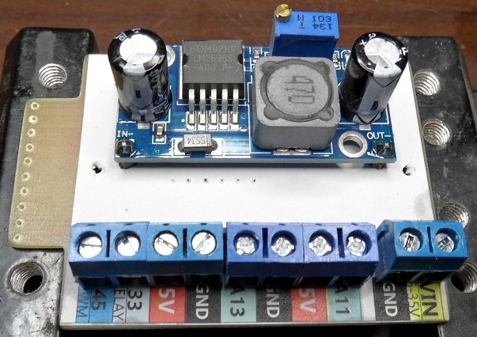
Top-PCB Terminals & Pin-Header  - Solder on a 6P Male Header from the back-side of PCB pushing pins down flush on the top as shown.  - NOTE: If using CUI Screw Terminals Remove Black after Solder  - Install & Solder 10-Merged Screw Terminals to PCB | 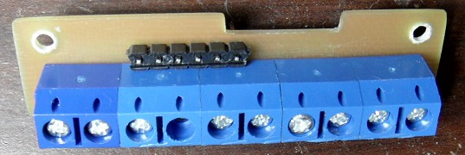
Top to Bottom PCB with 6P Female Header  - Plug a 6P Female Plug onto the Top-PCB male pins.  - Place the SIOST-Standoff.stl in front of the Power Module  - File Location: /Tode-SIOST/3DPrints/stl/SIOST-Standoff.stl  - Place Top-PCB on Standoff & align 6P Header to Bottom-PCB holes.  - Solder the 6P Female Plug pins. | 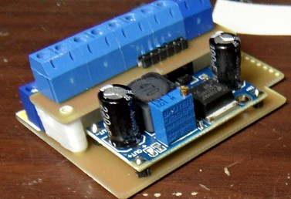
Side-IO Header & (2) Relay 3P Female Headers  - Install & Solder the Side-IO(SIO) Plug using 90° 10P Male Header.  - Bend (2) 3P Female Header pins to 90° and solder to back side of Bottom-PCB as shown. | 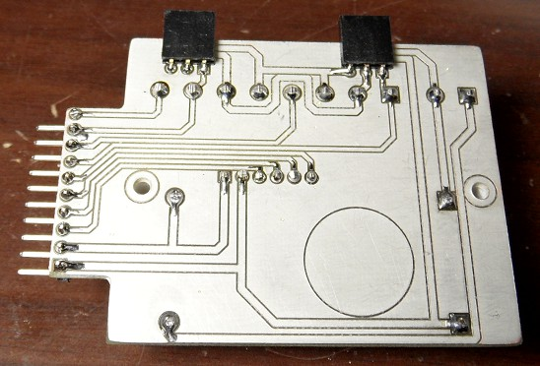

Schematic & Layout
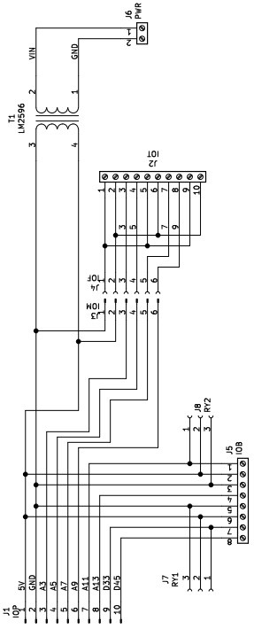 | 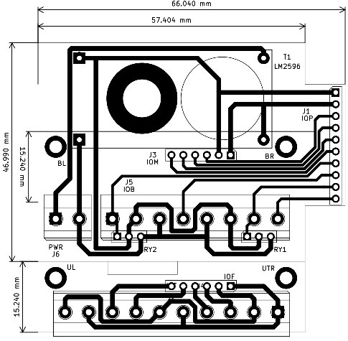
  T1 | LM2596 DC-DC Power
  J1 | Side-IO Plug | 1x10P 90° Male
  J3 | Top-PCB Plug-In | 1x6P Female
  J4 | Top-PCB Plug-In | 1x6P Male
  J5 | Screw Terminals | 1x10 Screw Terminals
  J6 | 1x2P Screw Terminal
  J7 | Relay #1 Plug-In | 1x3P Female PH
  J8 | Relay #2 Plug-In | 1x3P Female PH

Final Assembly

Final Assembly Steps

Power Module Cover  - Cut & Stick PS Cover Label from printed stickers sheet  - Stick it to /Tode-SIOST/3DPrints/stl/SIOST-PSCover.stl model.  - Cut out Top-Right Hole by “PWR” text and screw holes as shown. | 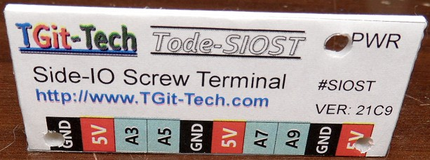
Adjust Power Supply Module  WARNING: Never Attach a Tode until Power Supply is Set to 5Vdc  - Wire-Up an adjustable DC Power Supply to VIN & GND of Module  - Attach a Volt Meter to VOUT+ and VOUT- of Module  - Be sure DC Power Supply is under 35Vdc and Turn it on.  - Adjust the Blue-Pot till Voltage Out is ~4.98Vdc  - Check VOUT is ~5Vdc while VIN is adjusted 6V to 30V.  - Apply Hot-Glue to the Blue Pot to keep static | 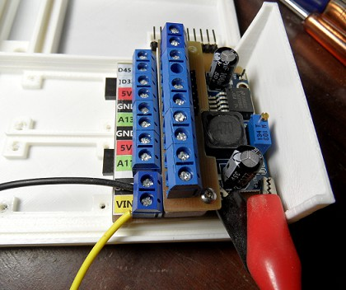
Screw PCB-Assemblies to Base  - Stack from Bottom to Top the following  - Bottom-PCB  - Standoff  - Top-PCB  - Power Supply Cover  - Fasten the Stack to the Base using (2) #2-56 x 1” Machine Screws | 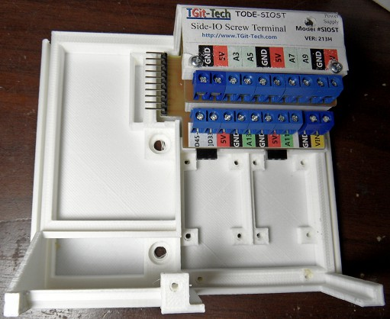
Cover Windows in Cover  - Cut (2) Clear Craft Plastic squares  - 38mm x 42mm for Tode-Display  - 56.5mm x 70mm for IO-Screw Terminals Window  - Trim to Fit  - Slide each into the SIOST-Cover.stl in appropriate spots  - Trim with scissors for a precise fit  - Seal Seams with Clear Adhesive Silicone  - Apply to inner-seam conservatively (No finger spread) | 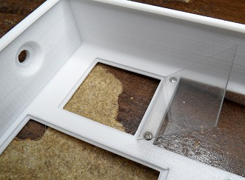
Install KBHood  - Fasten /Tode-SIOST/3DPrints/stl/SIOST-KBHood.stl to Cover  - Use (2) #2 – 1/4” Sheet Metal Screws  - Check that grooves mesh together | 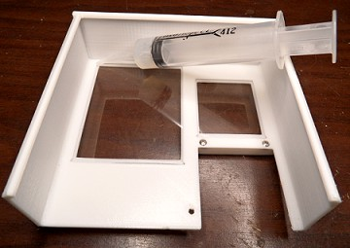
Install KBCover, Tode & Relays (Optional) in Base  - Fasten /Tode-SIOST/3DPrints/stl/SIOST-KBCover.stl as shown using (2) #2 – 5/8” Sheet Metal Screws  - Leave screws loose enough for flipping cover action  - Plug a Tode into the SIOST sliding right as shown.  - Attach and fasten Relays as shown. | 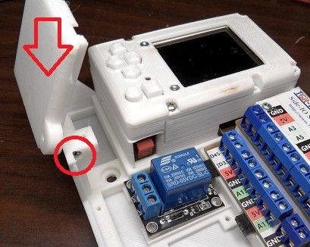
Attach Cover to SIOST-Base  - Align Cover back edges with Base groove outer-edges and slide down the base.  - Fasten in center of cover with (1) #2 – 5/8” Sheet Metal Screw  - NOTE: This screw can also be fastened on the outside of the KB-Cover to secure manual operation.  - Screw the Antenna to the Tode-RC  - Include Cable Entry Brackets and Plugs with Assembly  - (2) #4 x 1/2” Sheet Metal Screws for Back Cable Entry  - (2) #4 x 5/8” Sheet Metal Screws for Top Cable Entry  Slide into a 6x8in Ziplock bag | 

